|  |  |
| --- | --- |
| Ex. No.: 11 | **Discretization of Continuous System and Effect of Sampling** |
| Date: |

**Aim**

To write a Matlab code for discretization of continuous system and effect of sampling and understand the results.

**Procedure**

Step 1: Open blank script file in Matlab.

Step 2: Input the transfer function with delay and define the sampling interval.

Step 3: Use c2d function to convert continuous to discrete system and plot it.

Step 4: Use d2c function to convert back to continuous system and observe the reproducibility with respect to sampling time.

**Program**

close all;

clearvars;

% Transfer Function

G = tf([1 -2],[1 3 20],'inputdelay',1);

Ts = 0.1; % sampling interval

Gd = c2d(G,Ts);

Ts = 1; % 10 times larger than previously

Hd = c2d(G,Ts);

% Compare the continuous and discrete step responses:

figure;

step(G,'b',Gd,'r',Hd,'g--')

legend('Continuous','Discretized 0.1Ts','Discretized 1Ts')

figure;

Hc = d2c(Hd);

Gc = d2c(Gd);

step(G,'b',Hd,'r',Gc,'g--',10)

legend('Original','Discretized 1Ts','Discretized 0.1Ts')

**Output Waveform**

**Continuous to Discrete**

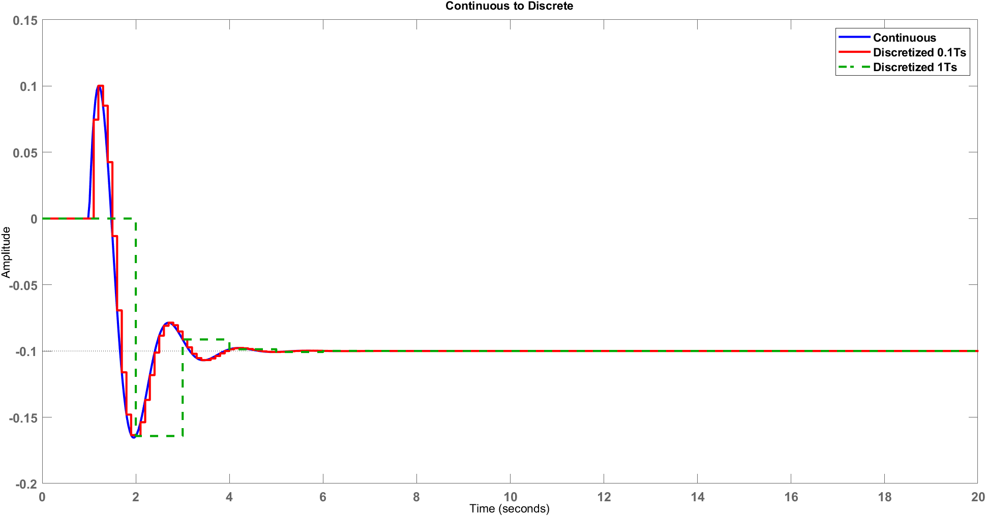

**Discrete to Continuous**

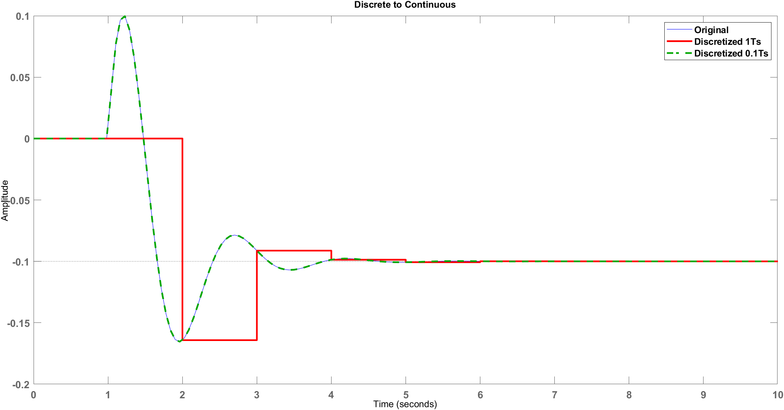

**Result**

Thus, the discretization of continuous system and effect of sampling is simulated in Matlab and the reproducibility is been observed.